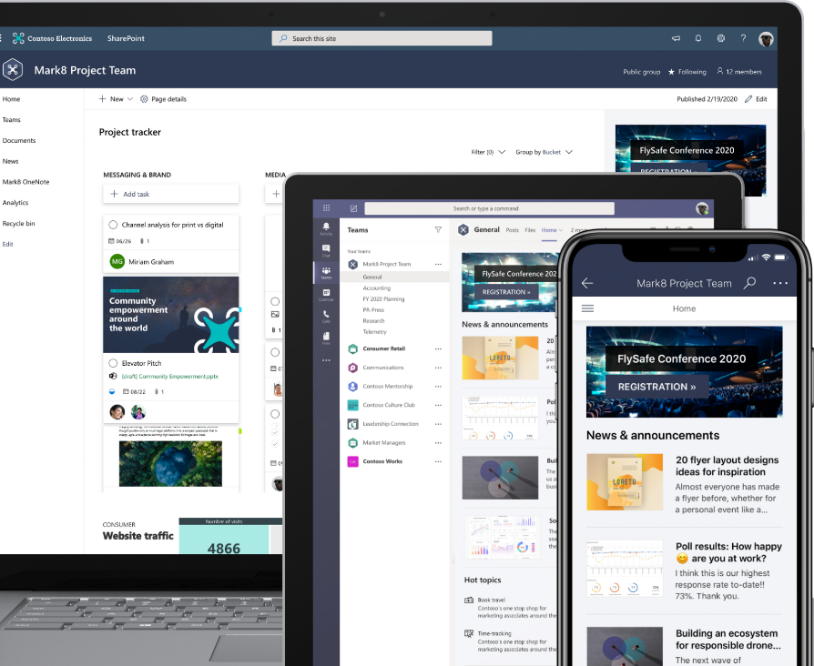
Simple sharing and seamless collaboration
SharePoint empowers teamwork with dynamic and productive team sites for every project team, department, and division. Share files, data, news, and resources. Customize your site to streamline your team’s work. Collaborate effortlessly and securely with team members inside and outside your organization, across PCs, Macs, and mobile devices.

Anywhere access
Your files are always with you with OneDrive. Save your files to OneDrive to keep them protected and accessible on all your devices, anywhere. Share files securely and collaborate in real time in Office. Plus, if your offline your edits will automatically sync the next time you connect.

Share inside and outside your organization
Confidently share your files with OneDrive so others can access them seamlessly and securely, inside and outside your organization. Track the history of all activity on files to keep everyone on the same page. Use SharePoint for managing and sharing files or folders—within team sites or intranet sites, and across your organization.

Find, co-author, and update files
- Work on a file, save it directly to OneDrive or SharePoint, and any changes you make are updated seamlessly.
- Deep integration with Office lets you start co-authoring a document on one device and finish on another, and you can select from a variety of tools to annotate, highlight, and comment on it.
Easily work on documents and share files in Microsoft Teams. OneDrive and SharePoint integration, along with apps such as Word and PowerPoint, help increase productivity, improve focus, and streamline collaboration.

Heading 1

Heading 3
Normal
- List Paragraph
Custom style

Normal with increased left indent. Normal with increased left indent. Normal with increased left indent. Normal with increased left indent. Normal with increased left indent.

